Assignment 13: Database Task

Date of Submission:15.05.2026
Name: Dhinesh B

Screenshots:

Insert Operations
1. insertOne()
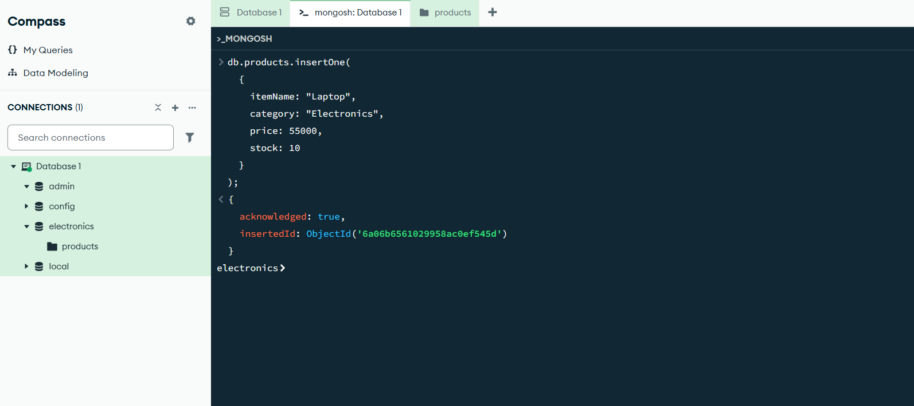

2. insertMany()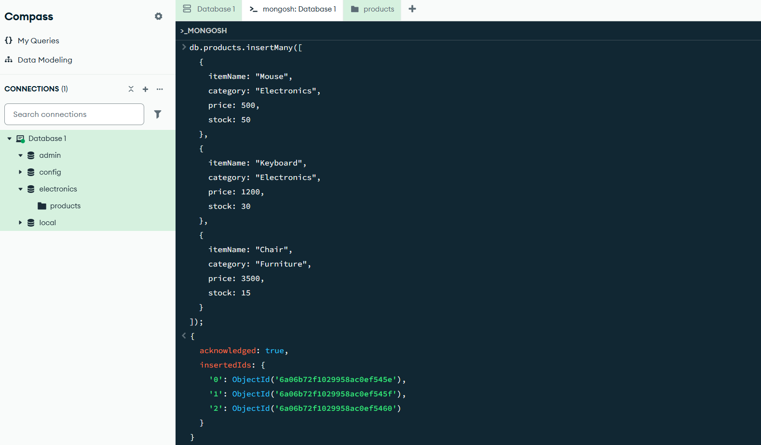

Read Operations
3. find()
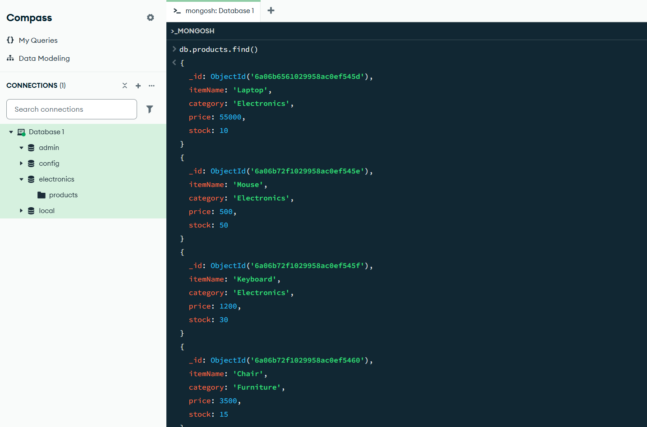

4. findOne()
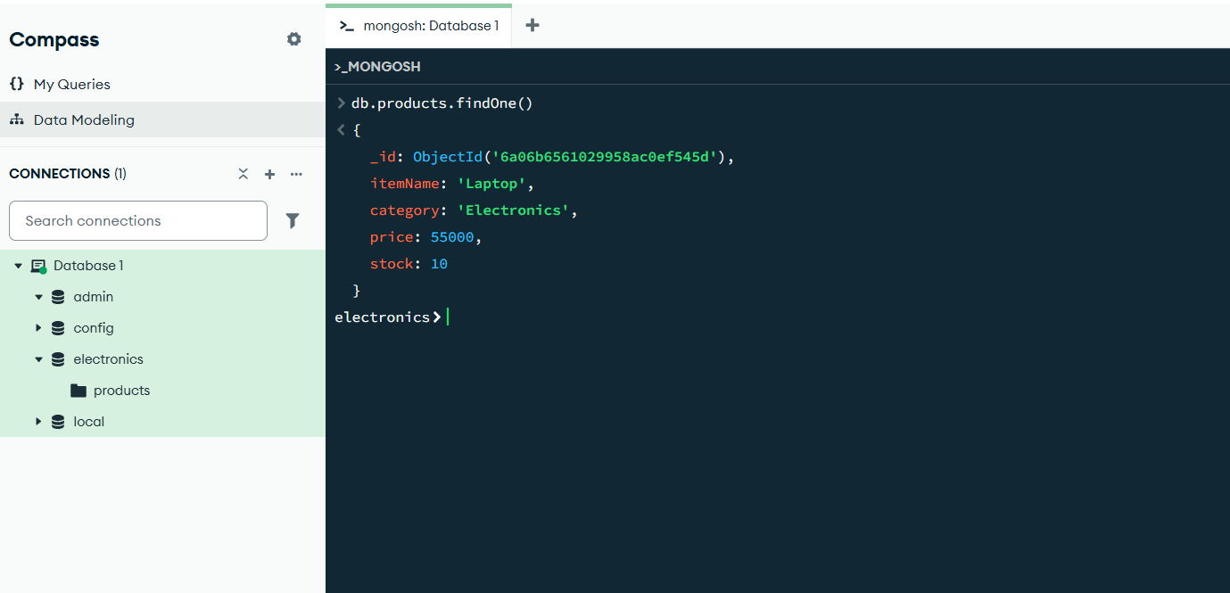

Update Operations
5. updateOne()
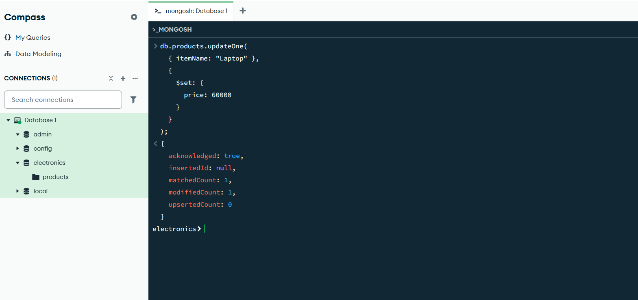
6. updateMany()
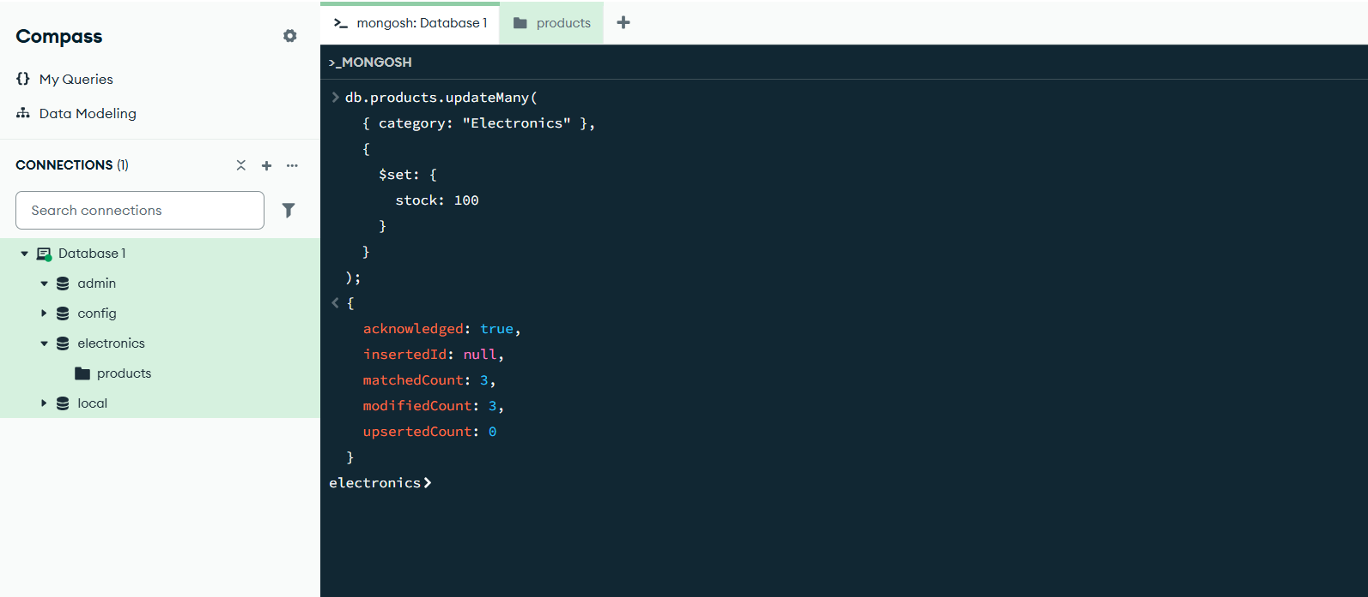

Delete Operations
7. deleteOne()
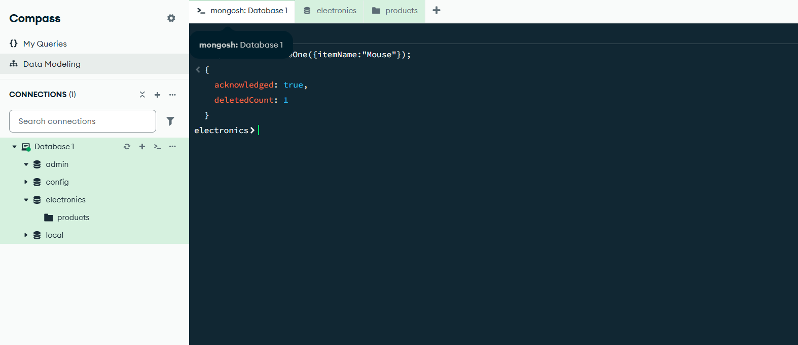
8. deleteMany()
